AMD INSTINCT MI455X · CDNA 5 · ROCm 10
Closing the RL loop with verl on MI455X
A reinforcement-learning step has to generate, train, and hand weights back — and on a brand-new architecture, every one of those can fail alone. Here is the first time all three held together on AMD Instinct MI455X: verl running GRPO on a 30B mixture-of-experts model for 100 steps, with the two halves of the loop agreeing to four decimal places on kernels neither had used before.
Hardware 4 × MI455X, 432 GB HBM4 each
Stack ROCm 10.0.0 · PyTorch 2.11 · verl 0.10.0.dev
Run 100 GRPO steps · 8.0 h
WHAT RAN
MI455X is the first CDNA 5 part, and the software that reinforcement learning depends on has not met it before. RL is a harder enablement target than inference or supervised training: a single step drives a generation engine and a training engine over the same weights, pushes updated weights between them every iteration, and needs the two to agree numerically or the policy gradient it computes is wrong.
This run puts verl through that loop on four MI455X cards — GRPO on Qwen3-30B-A3B, a 128-expert mixture-of-experts model, generating up to 8192 tokens per response against DAPO-Math-17k, with sglang serving rollouts and FSDP handling the actor.
COMPONENT | VERSION | NOTE
GPU | 4 × MI455X (gfx1250) | 432 GB HBM4 per card, driver 7.1.1
ROCm | 10.0.0
PyTorch | 2.11.0+rocm10.0.0
verl | 0.10.0.dev | FSDP actor, sglang rollout
sglang | 0.5.19 | triton attention, triton MoE runner
Transformer Engine | 2.17.0 | built from source for gfx1250
Model / data | Qwen3-30B-A3B | DAPO-Math-17k, 8 prompts × 8 samples
THE RESULT THAT MATTERS
Training and inference agree, on kernels that have never agreed before
Almost nothing in this run uses the kernel it would use on a CDNA 3 or CDNA 4 part. aiter's unified attention reads out of bounds on gfx1250, so rollout attention goes through triton. Composable Kernel's fused MoE is built on XDLOPS, a matrix instruction this architecture does not have, so the MoE runner goes through triton too. There is no flash-attn build, so the actor falls back to sdpa. Transformer Engine and apex have no published wheels and were compiled from source.
Every one of those substitutions is a chance for the generation side and the training side to compute slightly different probabilities for the same tokens — which would corrupt the policy gradient silently, with no error and no crash. So the measurement that matters is not throughput. It is whether the two sides still agree.
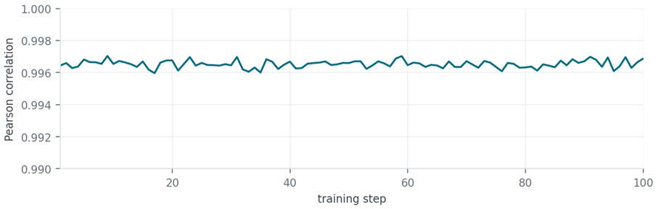
Figure 1. Pearson correlation between the actor's and the rollout engine's token probabilities, every step. Flat at 0.9965 ± 0.0003 for 100 steps — no drift.
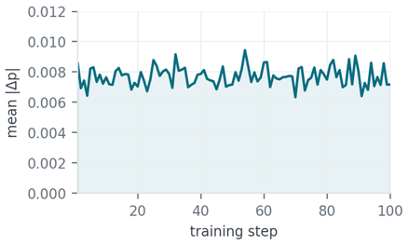 | 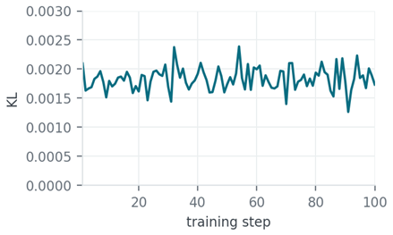
Figure 2. Mean probability difference (0.0077 average, band 0.0063–0.0094) and rollout–actor KL (0.00183 average). bf16 rounding, not drift.
0.0077 is what bf16 inference costs in absolute probability terms, and the correlation holding to four decimal places for eight hours is the evidence that the triton fallbacks this part needs are numerically trustworthy rather than merely non-crashing.
STABILITY
Gradient norm held at 0.124 for the whole run, and peak allocation never moved off 75.6 GB after the first ten steps — 17% of the 432 GB each card carries, which is the headroom a larger batch would spend. Neither figure is a tuning result; both are what a correctly enabled stack looks like when nothing underneath it is going wrong.
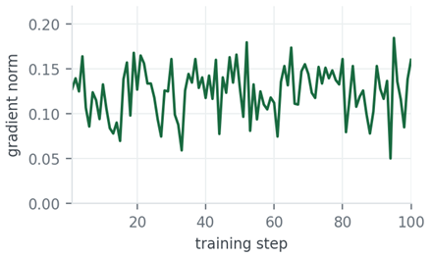 | 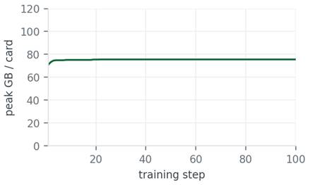
Figure 3. Gradient norm (mean 0.124, no divergence) and peak allocation per card (75.6 GB, flat from step 11 onward, of 432 GB available).
WHERE A STEP SPENDS ITS TIME
A step is one rollout of 64 sequences at up to 8192 tokens, a log-prob pass over them, the actor update, and the weight push back to the engines. None of this configuration has been tuned for speed — the batch was chosen to match a side-by-side run on another framework, and 64 concurrent sequences leaves four 432 GB cards a long way from saturated. What the split does show is that the loop behaves the way an RL loop should on a part where it works.
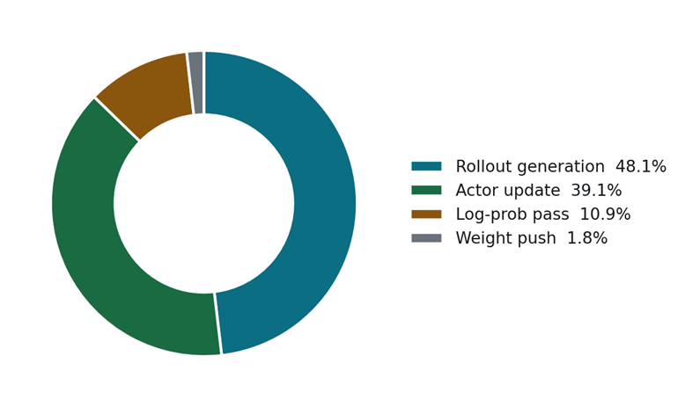
Figure 4. Share of step wall-clock by phase, averaged over 100 steps.
Generation and the actor update take 87% of the step between them, split almost evenly — which is what you want to see, because it means neither half of the loop is being starved by a problem in the other. The weight push, the step that hung for the full watchdog window before the collective settings were right, is now 1.8%.

BRINGING UP THE ROLLOUT SIDE
sglang serves generation, and on gfx1250 three of its kernel paths resolve differently than they do on CDNA 3 or CDNA 4. Getting them right is not a matter of turning acceleration off — two of the three keep their accelerated path, and the one that has to fall back is specific.
Attention falls back; MoE routing must not
aiter's unified attention kernel reads out of bounds on this part. It is not load-driven — we saw it take two schedulers down at 6% KV-cache occupancy with 65 concurrent requests, both dying with "Memory access fault: page not present or supervisor privilege" inside kernel_unified_attention_3d_…_ALL_DECODE_1. Attention therefore goes to triton.
The instinct at that point is to disable aiter wholesale, and the upstream ROCm image does exactly that for the older parts. On gfx1250 that breaks generation in a different place: sglang's MoE router checks _use_aiter first and, failing that, only reaches its triton router on a _is_cuda branch. ROCm falls through to sgl_kernel's compiled topk_softmax, which fails here with "unspecified launch failure" — during CUDA-graph capture and again in the forward pass. The routing kernel's only working path on ROCm is aiter's, so aiter stays enabled and attention alone is redirected.
Expert compute has no XDLOPS to build on
Both aiter's and Composable Kernel's fused MoE are built on XDLOPS, the CDNA matrix instruction. gfx1250 does not have it, so the JIT build fails outright and a 128-expert model never loads. The expert GEMMs go through sglang's triton MoE runner. The same constraint reaches aiter's own JIT: CK's buffer-addressing headers do not compile for this part at all, so ENABLE_CK=0 has to be set or a run dies mid-flight building module_sample.
With routing on aiter and expert compute on triton, CUDA graphs capture and run normally — the capture failures we first saw were the routing kernel, not the graphs.
BRINGING UP THE TRAINING SIDE
Transformer Engine and apex are source builds
Neither publishes a gfx1250 wheel. Both are compiled into the image, and Transformer Engine's fused attention is unavailable on this part regardless — it is unavailable in AMD's own Primus gfx1250 image too, so the actor runs TE's unfused path. There is likewise no flash-attn build, which matters more than it sounds: verl asks transformers for flash_attention_2 by default and transformers raises rather than falling back, so the actor has to be told to use sdpa explicitly. Transformer Engine's grouped GEMM has the same XDLOPS problem as the MoE runner, and takes the same answer — NVTE_USE_GROUPED_GEMM_TRITON=1.
Load width, not compute width, is what fills host memory
verl materializes the checkpoint at model_dtype, which defaults to fp32. For a 30B model that is 122 GB per rank; four ranks loading at once took a 251 GB host from 59 GB to 249 GB in ten seconds and Ray's OOM killer ended the run. model_dtype=bf16 halves it, and it is a distinct setting from param_dtype, which was already bf16 and governs the sharded compute rather than the load. Peak host use drops from 249 GB to 114 GB.
THE COLLECTIVE BETWEEN THEM
Every iteration pushes updated weights from the actor to the rollout engines, and this is where the hardest problem on this part lived. With the ROCm defaults, the first weight broadcast never returns:
Watchdog caught collective operation timeout:
WorkNCCL(SeqNum=37730, OpType=BROADCAST) ran for 1800028 milliseconds
The full 1800-second watchdog window elapses, both sglang schedulers abort, and the job dies. Nothing in the symptom points at a cause — a collective timeout looks the same whatever produced it, and it arrives after the rollout and the training step have both already succeeded.
The settings that fix it come from AMD's own Primus, whose gfx1250 environment files are the only place they are written down for this part. The one that matters is almost certainly MSCCL and MSCCL++ — RCCL's alternative collective implementation, which Primus disables on gfx1250. With it off, the same broadcast completes in 4.3 seconds.
Two more are worth calling out. NCCL_MIN_NCHANNELS is pinned at 112 by the base image for gfx950; on a four-GPU node forming small communicator groups that is a lot of channels, and the MI455X variant clears it. And NCCL_IB_DISABLE is deliberately not baked into the image — it is a single-node choice, and Primus's own comment notes that naming InfiniBand devices the host lacks stalls RCCL init. It is passed at run time instead.
SETTINGS THAT DIFFER ON MI455X
Everything below is baked into the image except the last row. Each is here because a run fails or hangs without it, not as tuning.
SETTING | VALUE | WHY THIS PART NEEDS IT
ROLLOUT
SGLANG_USE_AITER | 1 | MoE routing has no other working path on ROCm; disabling aiter drops it onto a kernel that fails to launch
SGLANG_ATTENTION_BACKEND | triton | aiter's unified attention reads out of bounds here
moe_runner_backend | triton | fused MoE is built on XDLOPS, which gfx1250 does not have
TRAINING
NVTE_USE_GROUPED_GEMM_TRITON | 1 | same XDLOPS constraint inside Transformer Engine
model_dtype | bf16 | fp32 default materializes 122 GB per rank at load
attn_implementation | sdpa | no flash-attn build; transformers raises instead of falling back
ENABLE_CK | 0 | Composable Kernel does not compile for gfx1250
COLLECTIVES
RCCL_MSCCL_ENABLE / RCCL_MSCCLPP_ENABLE | 0 | the weight broadcast hangs for the full watchdog window with these on
NCCL_MIN_NCHANNELS | cleared | base image pins 112 for gfx950; too many for a 4-GPU node's groups
TORCH_NCCL_USE_TENSOR_REGISTER_ALLOCATOR_HOOK | 0 | known to stall in weight-broadcast paths
GPU_MAX_HW_QUEUES | 2 | Primus's gfx1250 default
PYTORCH_ALLOC_CONF | expandable_segments:True | keeps large activation allocations from failing on a fragmented pool
NCCL_IB_DISABLE | 1, at run time | single-node only — baking it in would break a multi-node job
ONE PATCH THE FRAMEWORK NEEDS
Between the sglang version verl pins and the 0.5.19 this image ships, update_weights_from_tensor became a three-part session — begin_weight_update, the tensor updates, end_weight_update — and the scheduler asserts the session is open. Without a wrapper the run dies at its first weight push, again after both halves of the step have already succeeded. verl reaches sglang over HTTP, so the wrapper belongs on both HTTP adapters; patching the direct engine call leaves the path that actually runs untouched.
REPRODUCING IT
docker pull rocm/pytorch-private:verl-rocm10-mi45x
docker run --rm --device=/dev/kfd --device=/dev/dri --group-add video \
--security-opt seccomp=unconfined --ipc=host --shm-size=64g \
--ulimit memlock=-1 --ulimit stack=67108864 \
-e NCCL_IB_DISABLE=1 \
-v $MODELS:/root/models -v $DATA:/root/datasets \
rocm/pytorch-private:verl-rocm10-mi45x \
bash examples/grpo_trainer/run_qwen3_30b_a3b_mi45x.sh
The image carries the gfx1250 environment and both patches. NCCL_IB_DISABLE is passed at run time rather than baked in, since it is a single-node choice.
MEASUREMENT DETAILS
Measured on 4 × AMD Instinct MI455X (gfx1250), ROCm 10.0.0, driver 7.1.1.31300009
verl 0.10.0.dev · sglang 0.5.19 · Megatron-LM 0.19 · Transformer Engine 2.17 · PyTorch 2.11
100 GRPO steps on Qwen3-30B-A3B / DAPO-Math-17k
8 prompts × 8 samples · 8192-token responses · lr 1e-6 · 8.0 h wall clock

